Ideation Phase

Empathize & Discover
Date | 02 November 2025
Team ID | NM2025TMID06828
Project Name | Streamlining Ticket Assignment for Efficient Support Operations
Maximum Marks | 4 Marks

Empathy Map Canvas:
In the Empathize & Discover phase, the team studies how support agents and managers handle ticket assignments. They observe that delays and confusion often occur when tickets are not properly categorized or assigned to the right person. Agents feel overburdened with tickets that are not related to their expertise, while some tickets remain unattended for a long time.
By interviewing support staff and analyzing workflow data, the team identifies that lack of automation, poor prioritization, and unclear ownership lead to inefficiencies and reduced customer satisfaction. These gaps highlight the need for an automated and intelligent ticket assignment system that ensures faster resolution and balanced workloads.
These insights help the team understand how unorganized assignments affect response time and morale. Recognizing users’ pain points and expectations helps guide the design of a more transparent, fair, and efficient support process

Empathy Map Explanation:
The empathy map helps us understand how support teams experience challenges in assigning and resolving tickets.
It highlights their thoughts, frustrations, and needs, allowing us to create a smarter and more user-centric solution.
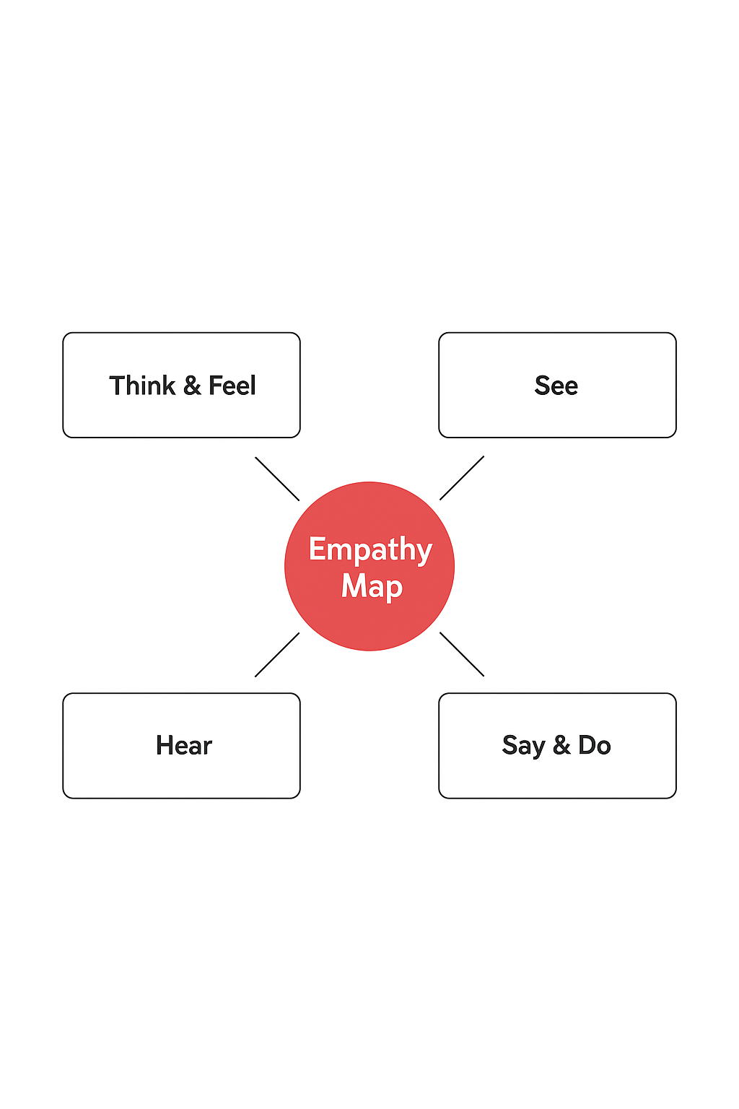

By deeply empathizing with the users, we identified the root causes behind ticket mismanagement — such as manual assignments, lack of visibility, and unclear prioritization.
The insights revealed the need for:
- Automated ticket routing based on expertise and workload.
- Real-time monitoring of ticket ownership.
- Clear communication and reassignment alerts.
As a result, the proposed system improves support efficiency, agent productivity, and customer satisfaction, ensuring every ticket is handled promptly and by the right expert.

